

**SCHOOL OF SCIENCE**

**DEPARTMENT OF MATHEMATICS AND COMPUTER SCIENCE**

**COURSE: BACHELOR OF SCIENCE IN COMPUTER SCIENCE**

**PROJECT TITLE: NATIONAL IRRIGATION BOARD MANAGEMENT SYSTEM**

**STUDENT NAME: PATRICK OSBERT MAYABI**

**REG.NO: COM/058/13**

**COURSE TITLE: COMPUTER SCIENCE PROJECT 2**

**THE NATIONAL IRRIGATION BOARD MANAGEMENT SYSTEM**

This documentation submitted to University of Eldoret in partial fulfilment of the requirements for the award of the degree of Bachelor of Science in Computer Science

# DECLARATION

I, ***Patrick Osbert Mayabi*** registration number **COM/058/10**, do hereby declare that this is my original work and that it has not been submitted, transferred by any other student for a degree or any other course in this institution or any other institution of learning.

**Patrick Osbert Mayabi**

**Signature**……………………………… **Date**……………………………………………

**{All rights reserved.}**

**Supervisor Approval**

This project has been proposed, developed, supervised and submitted for examination with my approval as the Supervisor.

**NAME: Mrs Lilian Siele**

**Signature**…………………………………. **Date**…………………………………………….

# DEDICATION

I dedicate this project to my parents for their continued support to ensure I attend and complete all the necessary classwork, assignments and research in completion of this project, my classmates and friends for helping me in different matters regarding my stay, research and attempts to effectively complete this project, and my supervisor for her professional support in research and development of this project. Her constant reminders, constructive criticism and unending feedback has been of un measurable help in the completion of this course. Finally, I dedicate this project to my lecturers and the department of Mathematics and Computer Science of University of Eldoret for their support and guidance.

# ACKNOWLEDGEMENT

The prayers and dedication I have made to the Almighty God have seen me through this. For the good care and good health God has been good. During the project development period, my parents have supported me in all the ways they could. I cannot thank them enough for the financial support, for the comfort they gave me, for their continued interest in my wellbeing and for all the times they encouraged me to keep going. My collective gratitude goes to my supervisor, Mrs Lilian Siele and the entire ICT department at University of Eldoret. For her guidance and patience during this project and her helpful correction and recommendations. Finally, to all my contributing lecturers, classmates, friends and everyone who supported me to the successful completion of this project.

# CHAPTER ONE: INTRODUCTION

* 1. **Introduction**

The world is moving fast from analog and simple computerized systems to more advanced and sophisticated systems in all fields of life. The fact that this has made operations both personal, business and industrial, more efficient and effective cannot be ignored. People and organizations are constantly accelerating toward adoption of technological options that place them, their lives, and businesses on the higher end of achieving competitive advantage. The use of computerized systems therefore comes with a wide range of advantages. Computerized systems are automated, and calculations are handled by software, eliminating possible errors and saving time. For instance, automatic processing of invoices makes accounting less time-consuming.

Computerized systems are designed for accuracy to the smallest detail. Once the data is entered into the system, calculations for functions such as payroll and billing are performed quickly and efficiently by accounting software programs. Computerized systems make it easier for different individuals to access data even outside the office. One can access accounting records quickly without having to sift through stacks of papers. Accuracy of calculations of computerized system ensures reliability of financial statements prepared by computers. Computerized systems store data in off-site locations, ensuring safety from natural and man-made disasters such as fires.

Agriculture is the backbone of most developing economies and employs a majority of the working age population in these countries. **Agriculture employs over 60 percent of Africa’s workforce and it is the largest economic sector representing 15 percent of the continent’s GDP.** There is therefore need to ensure the systems used in agriculture support its rapid development and makes work easier for the farmers and other stakeholders in the agricultural field**.**

Like all the other industries, the agricultural industry has profoundly advanced in the use of technology. Technology is transforming the agricultural sector through:

1. **Detection of disease, pests, or weed**; Through the use of satellite imagery and drones, precision agriculture is adding value to farming through the use of hyperspectral imaging used to detect diseases, pests, and weeds. Timely response enables farmers to mitigate losses that may result from such diseases and pests thus improving yields.
2. **Genetically produced plants**; With the use of technology, plants such as potatoes and cassavas that are genetically produced are usually resistant to droughts, pests and diseases. Such crops ensure good yields for farmers who would otherwise experience losses due to changing weather patterns.
3. **Cooling facilities**; Farm produce needs to get to the market while still fresh. Lack of cooling facilities increases post-harvest losses. It is estimated that a third of harvested produce goes bad due to lack of proper storage facilities. With cooling facilities installed in truck and farms, perishable goods such as tomatoes get to the market while still fresh.
4. **Irrigation of plants**: Only 5 percent of cultivated land in Africa makes use of irrigation. In dry areas, farmers are embracing technology to irrigate their crops. Farmers are using water pumps to collect fresh water and irrigate their crops. Fresh water collected from rivers and boreholes is used to boost production and is enabling farmers to plant crops throughout the year. More advanced technology uses sensors to collect information about the soil and water allowing farmers to determine the right time to irrigate their farms.
5. **Crop scouting**; Farmers can use mobile phones and tablets to collect data about their crops and use various platforms to analyze collected data. There are platforms that can make meaning out of the data farmers collect in the field. This assists farmers to monitor weed activity and pest populations on their farms enabling them to take appropriate measures thus boost their yield and consequently make more money.
   1. **Problem Statement and Definition**

**The agricultural sector is faced with several challenges ranging from climate change to water scarcity**. Without the right tools and knowledge, productivity can be hampered and farmers left counting losses. Technology is providing an unprecedented opportunity to improve yields and mitigate some of the losses associated with the various challenges in the agricultural sector. **Adoption of technology is increasing rapidly due to the tremendous value technology brings to farmers**. Smallholder farmers in Kenya are more susceptible to the risks that come with lack of information and knowledge on changing weather patterns, determining the right time to plant, and market prices of the various produce. Technology is enabling stakeholders to collect agricultural data and use that data to advise farmer on how to boost their yields

Rice growing in Kenya is typically based on irrigation schemes, with an approximation land coverage of 13000 ha. Most of the rice produced in Kenya comes from national irrigation schemes where rice production is based on recurrent flooding of paddy soil. Studies have shown that soil fertility in the region is medium to high in terms of nutrients composition therefore suitable for average rice production. Despite the suitable nutrients’ composition, most of the regions in Mwea have become stagnant in terms of rice production which has been fronted by soil degradation. Identifying possible nutrients hotspots could be an initial point of identifying nutrients deficiencies, toxicity levels, and ph.

Concentration in soil and indorse appropriate agricultural practices, such as right quantities of fertilizer applications, chemical applications to avert the degradation effects. Accordingly, there is a need to store such data in a system that tracks changes in soil composition. In essence, if the system shows a consistent soil composition at a certain season or region, it is easy for the board to recommend appropriate measure and even predict soil nutrients composition changes, therefore easier to advise farmers. To acquaint you with a broader repertoire, the National Irrigation Board lacks a substantive inventory system, therefore the proposed system will store data regarding nutrients compositions across different regions and automate manual record keeping.

**1.2 Background Information on the Target Area**

Mwea Irrigation Settlement Scheme (MIS) is located in Kirinyaga County and falls within two sub counties i.e. Mwea East and Mwea West sub counties. Development of the scheme started in 1954 from the Tebere section with about 65 acres in irrigation farming and has since grown to the current gazetted area of 30,050 acres. Out of these, 22,000 acres have been developed for paddy rice production while the remaining area is utilized for settlement, public utilities and growing of subsistence crops. Since then, expansion has been done to the freehold area (referred to as out-growers) surrounding the scheme by a total of 4,000 acres; hence the total area under paddy rice production in MIS is 26,000 acres of irrigation farming.

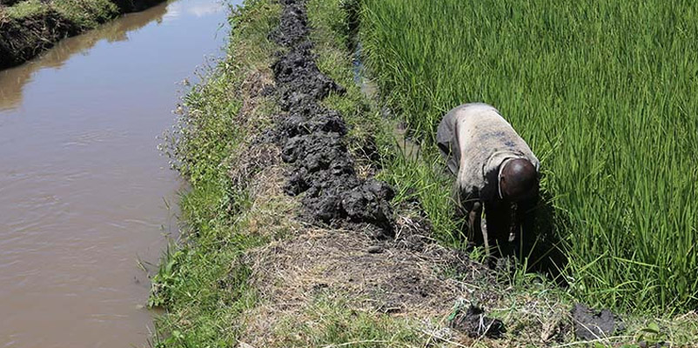

Figure 1: Farmer at Mwea(Source National Irrigation Board, 2021)

The National Irrigation Board (NIB) has improved, rehabilitated and developed irrigation infrastructure for the farmers to engage in production activities. The scheme lies along the drainage basins of Rivers Nyamindi and Thiba which supply the irrigation water. There is still potential of up to 10,000 acres for expansion within the surrounding areas. However, this is constrained by lack of sufficient water for irrigation. The scheme area is largely plane and predominantly covered with black cotton soils, with a few raised spots of red soil. Rice paddies have been developed on the low areas that are covered with black cotton soils while the high spots covered with red soils have been reserved for settlement and production of upland crops.

The current approach to scheme management is Participatory Irrigation Management (PIM), where the government through National Irrigation Authority and the farmers through their organizations (Irrigation Water User Association [IWUA], Mwea Rice Growers Multipurpose [MRGM] and Lainisha Sacco) have partnered in management of the irrigation scheme. Each of the four i.e. the Authority, IWUA, MRGM and Lainisha, have clearly defined roles in PIM. The Irrigation Authority’s key responsibility in scheme management is operation and maintenance of the primary and secondary infrastructure; while the farmers are responsible for the tertiary infrastructure. Other roles include land administration, capacity building, irrigation expansion and rehabilitation of the irrigation infrastructure.

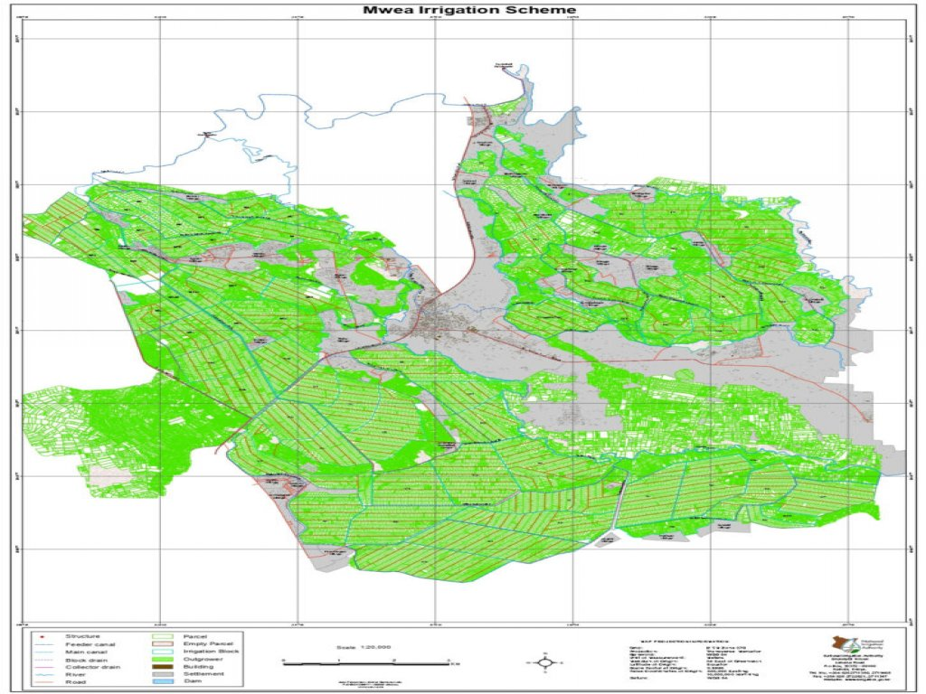

Figure 2: Mwea Scheme Layout Map (Source: National Irrigation Board,2021)

**1.3 Objectives and Motivation**

The main objective of the project is to create a desktop application that enables rice irrigation boards across the Mwea region to calculate nutrients composition across different regions as well as automate manual inventory tasks at the organizations. The system should also help the board to assess soil composition and make helpful recommendations to the farmers on the most favorable farm practices according to the results of the tests.

The motivation to develop this project is spearheaded by:

* An interest to create a system that achieves efficiency, and productivity in the operation
* Interest to minimize inventory cost and maximize sales at the irrigation board.
* An interest to integrate the entire business
* Automation of inventory work, therefore, saves time and effort to do an inventory recount.
* Keep track of soil conditions in the regions.
* Ensure accurate record keeping.
* Ensure that the farmers are happy and the overall rice production in the region are uplifted.
* Increase my knowledge horizon in technologies such as SQLite, python and its frameworks such as Tkinter.

# CHAPTER TWO: PROJECT DESCRPTION AND JUSTIFICATION

1. **Project Overview**

Plants need nutrients for germination, growth, fight pest and diseases and reproduce. With a wide variety of nutrients composition, soil acts as the epicenter of plant growth. The soil nutrients are divided into micronutrients and macronutrients, nonetheless, nutrients composition is not limited to plant species, and rather nutrients composition is based on crop variety. Macronutrients are nutrients that are by large necessitated by crops during the development period, such as nitrogen, phosphorous, potassium, magnesium, and calcium. As much as micronutrients are required in small quantities they play a vital role in plant growth. Such nutrients include Boron, Iron, and Zinc.

In crop farming, crop production is reliant on the nutrients supplied to the crops, or even the crop farming strategy assimilated by the farmer, for example, the farmer may decide to add compost manure as a nutrient supplement or as a strategy to improve soil water retention capabilities. Ideally, soil composition is composed of organic matter (5%), water (20-30%), mineral (45%), and air (20-30%). Soil composition is dynamic and complex therefore, it may fluctuate or vary depending on the soil type, water availability and retention capacities, Farmers’ cultivation practices, etc.

In Kenya’s food supply metric, rice farming is considered, the third staple food after maize and wheat. Like any other crop, rice farming undergoes processes such as planting, pest and disease control, fertilizer application and harvesting. It takes about four to five months for rice crops to become mature. Rice farming is dependent on the type of soil, nonetheless, most of the rice crops are grown in paddy soil. Various varieties of rice crops include Sindano, Basmati, Pishori, Aromatic, Basmati 370, Basmati 217, BW 196, Jasmine-85, NARIKA 10, NARKA 1, Nam Roo, WAB 181-18, and ITA 310.

* 1. **Basic Rice Growth Requirements**

**Climatic Requirements**

In Kenya rice is grown under widely varying conditions of altitude and climate. Rice cultivation in Kenya extends from 8 to35ºN latitude and from sea level to as high as 3000 meters. Rice crop needs a hot and humid climate. It is best suited to regions which have high humidity, prolonged sunshine and an assured supply of water. The average temperature required throughout the life period of the crop ranges from 21 to 37º C. Maximum temp which the crop can tolerate 400C to 42 0C.

Other important climatic conditions for rice farming include;

* An ecological condition of annual rainfall gauging as from 800 mm to 2000 mm.
* The temperature of 20-36 degree Celsius
* Soil type: paddy soil with an average composition to a mixture of clay soil and sandy soil.
* Soil PH level: 4.5 – 7.0
* Land should be ploughed two weeks prior to sowing and flooding of the farm.
* Flooding is done to a depth of 10 cm, 15 days before transplanting the seeds.
* Weeding is carried out 4-5 weeks after transplanting and is carried out twice.
* Pest and disease control. Diseases include- blast, mottle, damping off, sheath bright, sheath rot.
* Pest includes leaf miners, rice borer, birds, rice sucking bugs, rice leafhopper, etc.
* Harvesting is done 5-6 months after planting. Dependent on the rice variety.
* Expected yield from a paddy soil: 25-30 sacks /acre.
  1. **Selection of Seeds**

The use of quality seeds in cultivation of rice is an important factor to get better crop yield. Therefore, proper care has to be taken in selecting seeds of the best quality. Much of the success in raising the healthy seedlings depends on the quality of seed. Seeds intended for sowing should satisfy the following requirements

* The seed should belong to the proper variety, which is proposed to be grown.
* The seed should be clean and free from obvious mixtures of other seeds.
* The seed should be mature, well developed and plump in size.
* The seed should be free from obvious signs of age or bad storage.
* The seed should have a high germinating capacity.

Before sowing the seed should be treated with fungicides which protects the seed against soil-born fungi and also give a boost to the seedlings.

* 1. **Macro and Micronutrients Prominence**

**2.3.1: Nitrogen**

* Encourages vegetative development of plants by imparting a health green color on plants
* Rice crops depend on nitrogen for the decomposition of matter
* During the rice growth period, rice requires nitrogen for early vegetation and panicle initiation stage
* Promotes tillering which would lead to better yields

**2.3.2: Phosphorous**

* Promotes growth at an early stage
* Promotes the development of strong root development
* Promotes early flowering
* Critical for producing maximum rice grains yields.
* Increases resistance to disease and strengthens rice stems.

**2.3.3: Potassium**

* Enhances the ability of crops to resist diseases and adverse conditions.
* Plays an important part in the production of starch.
* Improves the plants' ability to absorb other nutrients
* Influences tillering and branching of plants and increase grain weight.

**2.3.4: Calcium**

* Promotes activity of soil bacteria concerned with the fixation of nitrogen
* Assists in the development of good root systems.
* An essential component in the development of cell wall

**2.3.5: Zinc**

* Important in the synthesis of carbohydrates
* Regulates consumption of sugar
* Acts as a metal activator of enzymes
* Rice crop removes 30-40 g Zn per ton of grain
  1. **Deficiencies**

Lack of nitrogen leads to:

* Stunted growth in rice
* Yellowing of leafs
* Abundant foliage
* Retarded flowering

Phosphorous deficiency

* Rice crops stunt with a reduced tillering
* Stems thin and spindly
* Poor branching in rice
* Poor root growth
  1. **Soil degradation in rice farms**

Soil degradation has become a common threat especially when it comes to paddy and loam soil. Maybe, with the high intake of nitrogenous and phosphoric components, the soil loses its ability to absorb more nutrients. Soil degradation occurs when the soil loses its chemical, biological, and physical composition therefore losses its soil fertility. Soil degradation is a general term representing loss of organic matter in the soil, reduction of soil fertility in the soil, higher changes in soil acidity levels, alkalinity levels, salinity, change in soil structural conditions, or even accumulation of toxic chemicals in the soil. Crop practices and fertilizer application criteria have registered to affect micronutrient availability, and structural condition of the soil (Haifa Group, 2020).

Accordingly, studies have satisfied that soil pH, a nutrient composition such as phosphorous and organic matter composition affects macro and micronutrient availability under various soil conditions. PH level plays a crucial part in soil composition as it acts as a predictor towards the estimation of heavy metals in the soils. Consequently, soil ability to provide micronutrients directly to the crops is a dependent factor towards the physiological function of the plants, structural development of the plants, and better product quality. The need for rice consumption has increased rapidly per capita. Following a EUCORD report (), the rice consumption rate commonly in the urban region has increased by 12%, compared to wheat at 4% and maize at 1%. Unfortunately, the country is a deficit to maintain such a huge ration. With such a deficit the country is forced to import rice from outside countries such as Pakistan, India, Thailand, and Vietnam.

* 1. **Determining Nutrient Composition**

Determining the nutrient compositions such as nitrates, potassium and phosphorous can assist to reveal how the soil is functioning and determine the cycle of nutrients in the soil. Often nutrients test provides average nutrients compositions (mg/L) of all the tested nutrients in that type of soil. In a rice farming setting, determine the nutrients composition in the paddy soil can assist know what type of fertilizer to apply, what quantity of fertilizer to apply, deficient nutrients that need to be supplemented or balanced, and determine the seed type that would be favorable in that soil condition. For example, higher nutrients levels in the paddy soil can surpass the flowering of the rice crops but with a balanced composition of nitrogen and phosphorous rice, growth criteria is optimal.

Following a Jove, Cambridge (2020) journal, the author delineates that “determining the nutrients composition assists the farmers to know the nutrients deficiencies and surpasses that can detriments rice growth. Most nutrients in the soil are removed after harvesting as the nutrients are utilized in rice development life cycle, For example, accumulation of nitrogen is high at the initial growth stage and later nitrogen is translocated to the grains after flowering. Accordingly, some nutrients such as zinc and phosphorous availabilities dependent on soil pH level. For example, if the soil pH is greater than 6.8 (pH>6.5) zinc is most likely to be deficient particularly if the rice variety is not tolerant of that soil condition. Accordingly, optimum availability of potassium occurs if the soil pH level range between 6 and 6.5. When the soil is acidic, potassium is absorbed by other nutrients such as iron and aluminium oxide.

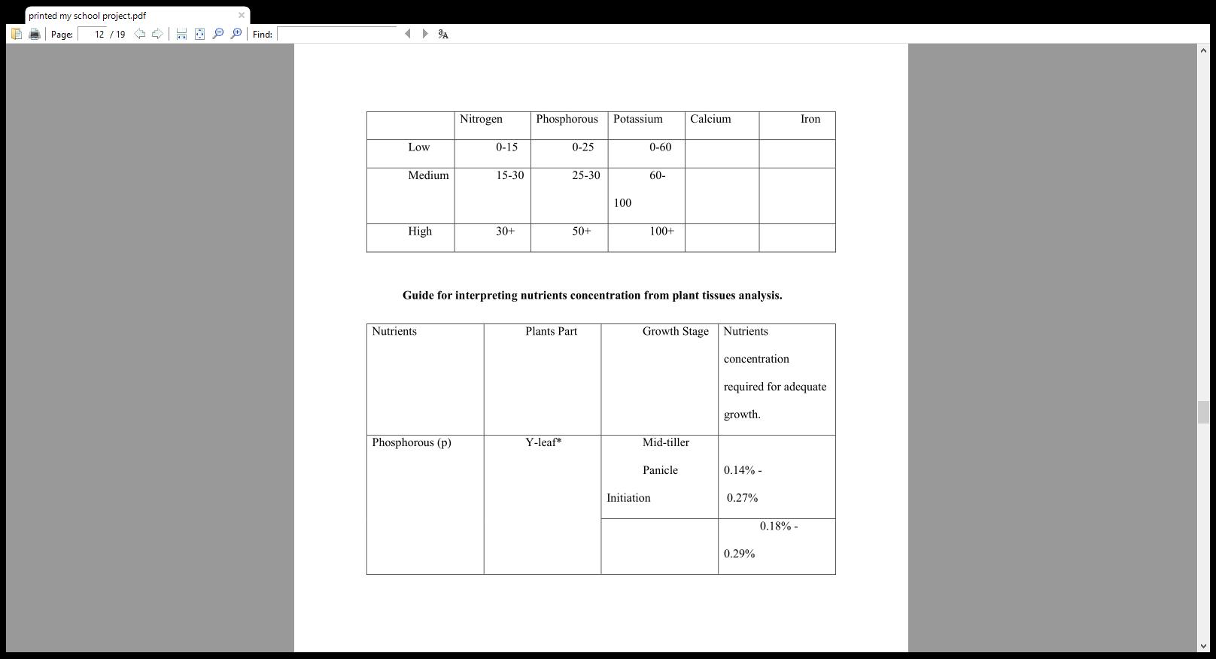

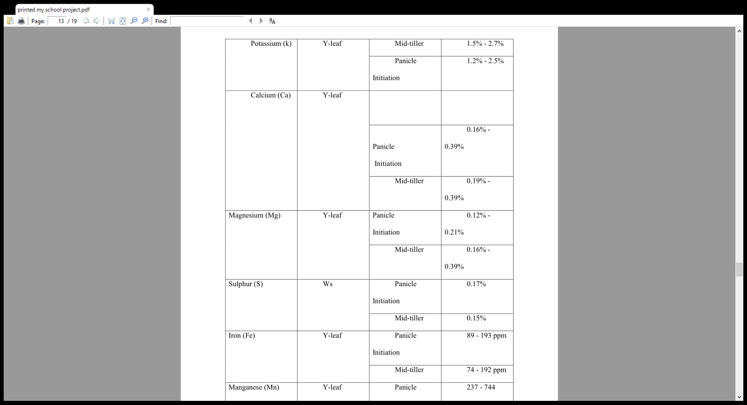

**2.6 The Proposed System**

The proposed system is a desktop-based application where the national irrigation board staffs can calculate various nutrients compositions in paddy soils. This software is developed to perform two tasks. First, the system will calculate the nutrients’ composition in a certain region, calculates the total composition of the selected nutrients and recommend the type of fertilizer, type of rice seed favorable in that soil condition. Accordingly, the recommendation will include nutrients percentages to be applied in the soil either to surpass or increase soil nutrients based on the soil pH level of that region. After calculating the nutrient requirement levels, the results are stored in the database, therefore a researcher or an interested farmer can refer to the prior compositions and relate various soil nutrient distributions across a given period. All records are saved in the database for report generating.

The second part of the system entails an inventory system, whereby the user inputs and a product name, assign a unique id to the product, enters the stock of the product, cost priced and selling price, total selling prices and cost prices and the vendor name. The inventory part of the system assists the organization to reduce the manual input and output of the product, instead, the system automates the process. As well the system can assist monitor and track and control transactions at the board. The software features a well thought and simple design, with an attractive user interface, combined with a search product capability, a comprehensive database storing each transaction singly and a printout option whereby users can print a transaction or even a recommendation. For example, consider a soil composition that has a nutrient percentage of nitrogen – 30%, phosphorous 25%, potassium – 15%, the zinc percentage of 18% and a pH level of 5.

The system will calculate the total composition of the soil in the tested region, then add the composition to the database. If the soil test results are wrong the users can edit the tests. In our case, the total soil composition is 88 indicating that the soils have a high nutrients composition. Thereafter the system will recommend the type of rice seeds that are favorable to that soil condition, the type of fertilizer to apply in such a soil condition to prevent overloading the paddy soil with nutrients chemical application and a recommendation on how to reduce or improve the soil pH level. After identifying soil requirements, the user can now add new products or update products in the inventory. For example, add a Basmati rice variety, to the database.

**Systems Configuration**

1. **Hardware configurations**

|  |
| --- |
| System: Intel (R) Celeron (R) |
| Hard disk: 500GB |
| Monitor: 15 “LED” |
| Input devices: keyboard, Mouse |
| RAM: 4GB |

1. **Software configuration:**

The coding language used to develop this system is python and tkinter. The system will therefore effectively run on any machine with a windows 7,8, or 10 operating system and using an SQLITE 3 database.

Other configurations include;

**Modules: Interface one.**

* Search: searches all product names by its assigned ID.
* Add to the database: adds the products ID, product name, stock of the product, cost price of the product, selling price, total cost and selling price, vendor name and vendor, vendor phone number.
* Update database: updates products ID, product name, stock of the product, the cost price of the product, selling price, total cost and selling price, vendor name, and vendor, vendor phone number
* Clear all: clears all fields in the systems.
* Calculate total: calculates the total composition of nutrients in the soil.
* Add composition: adds the total composition to the database.
* Suggest: providers' recommendations based on the total nutrients composition.

**Modules: Interface Two.**

* Search: Searches the product by its ID, and outputs product name and the price of that product.
* Add to Cart: adds the selected products, together with the quantity and total to the cart.
* Calculate Change: calculates the total change, after calculating the total amount in the cart and subtracting from the given amount.
* Generate bill: generates a bill showing the total products bought by the farmer, and the total amount and change.

# Conclusion

The national irrigation board management system is a software that tries to overcome the low production of rice in the national region by calculating the nutrients composition after every season as well as reduce the time and effort spent in record keeping. Making real time recommendations to farmers based on actual up to date analysis of their soil composition ensures farmers use the right seed, fertilizer and other farm products in production of rice. By automating the process, it is easier for the researchers to improve or introduce rice seed varieties that favour that soil condition. Accordingly, it will be easy to track different soil nutrients variation with time, therefore, the organization can recommend best practices that will improve crop yields.

**Further Scope**

This software can operate in any operating system and an agricultural sector that needs to improve crop production in that region. Modifications of the software can be easily done to suit the mandated environment. It can be used as an inventory system in a store, aiming to store daily transactions or actually automating the manual work in a store.

.

# Appendices

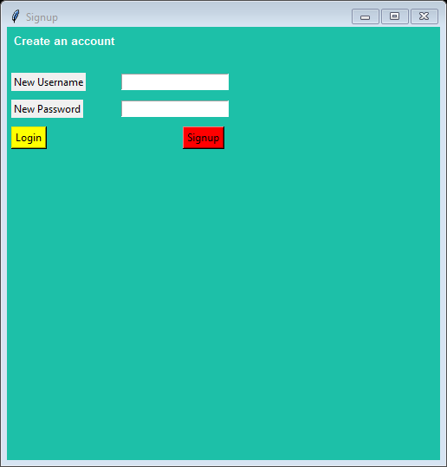

Figure 3: Signup/SignIn Interface

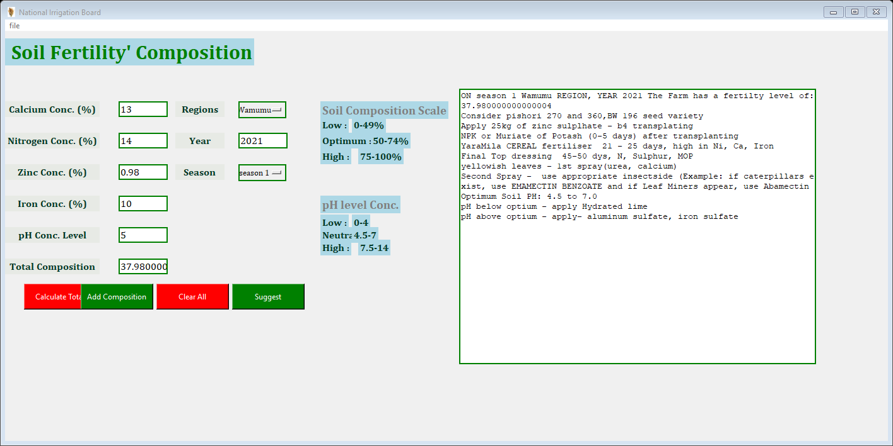

Figure 4: Soil Fertility Calculation Interface



Figure 5: Farmyard Practices Recommendation Report

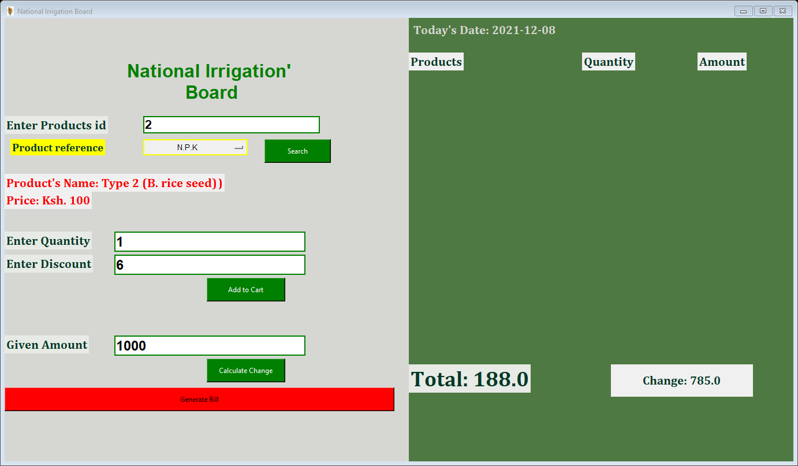

Figure 6: Transaction Interface for Farmers who shop at NIB

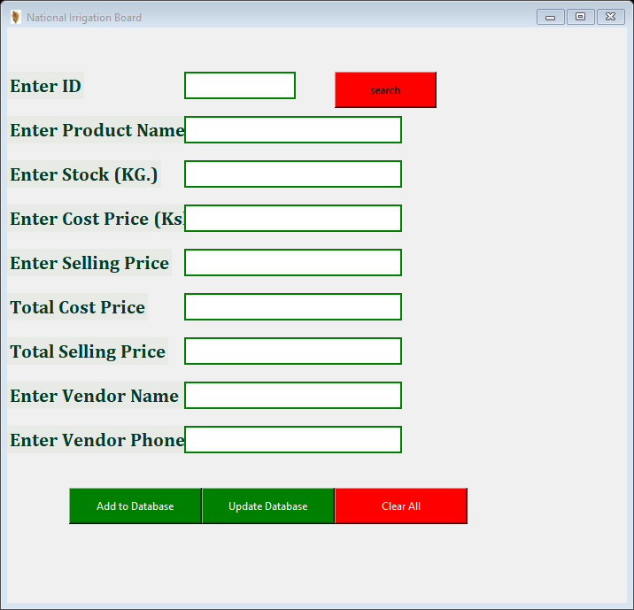

Figure 7: Inventory Page For NIB

# References

Jove, Cambridge, MA. (2020). Soil Nutrient Analysis: Nitrogen, Phosphorus, and

Potassium. Jove | Peer Reviewed Scientific Video Journal - Methods and Protocols.

https://www.jove.com/science-education/10077/soil-nutrient-analysis-nitrogen-

phosphorus-and-potassium

Crop Guide: Rice Fertilizer Parameters. (2020, February 23). Haifa Group.

https://www.haifa-group.com/rice-0/crop-guide-rice-fertilizer-parameters